Breakfast Wrap Menu dishes and their allergen content

Dishes | 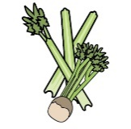 | 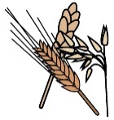 |  |  |  | 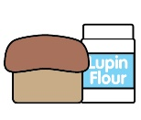 | 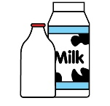 |  | 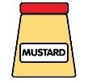 |  | 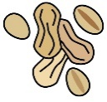 | 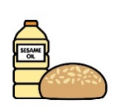 |  | 
 | Celery | Cereals containing gluten* | Crustaceans | Eggs | Fish | Lupin | Milk | Mollusc | Mustard | Nuts† | Peanuts | Sesame seeds | Soya | Sulphur Dioxide
Crumpets |  | X Wheat
New York Bagels |  | X Wheat Barley
Hovis Bread Best of Both |  | X Wheat |  |  |  |  |  |  |  |  |  |  | X
Jam
Butter (vegan)
Yoghurts |  |  |  |  |  |  | X
Tesco Malt Wheats |  | X Wheat Barley
Tesco Rice Snaps |  | X Barley
Tesco Honey Hoops |  | X Wheat Barley Oats

Review date: | 30/08/2026 | Reviewed by: | L BOYLE |  |  |  | You can find this template, including more information at www.food.gov.uk/allergy-guidance

Breakfast Wrap Menu Dishes and their allergen content

Dishes
 | Celery | Cereals containing gluten* | Crustaceans | Eggs | Fish | Lupin | Milk | Mollusc | Mustard | Nuts† | Peanuts | Sesame seeds | Soya | Sulphur Dioxide
Free From Yoghurts |  |  |  |  |  |  |  |  |  | MAY |  |  | X
Yoghurts |  |  |  |  |  |  | X

Review date: | 14/05/2026 | Reviewed by: | L BOYLE |  |  |  | You can find this template, including more information at www.food.gov.uk/allergy-guidance

