Wrap Menu dishes and their allergen content

Dishes | 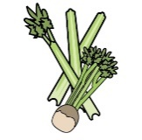 | 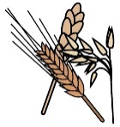 | 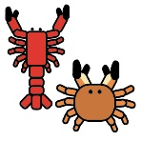 |  |  | 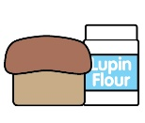 | 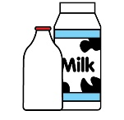 |  | 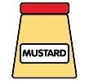 |  |  | 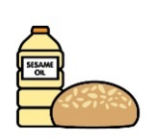 |  | 
 | Celery | Cereals containing gluten* | Crustaceans | Eggs | Fish | Lupin | Milk | Mollusc | Mustard | Nuts† | Peanuts | Sesame seeds | Soya | Sulphur Dioxide
Chicken Burger |  | X
Burger Buns |  | X |  |  |  |  |  |  |  |  |  | May
Tomato Ketchup | X
Tesco Potato Waffles
Spagetti Hoops |  | X |  |  |  |  | X
Wraps |  | X
Tesco Ham (Eastmans)
Sliced cheese |  |  |  |  |  |  | X
Hot dog rolls |  | X |  |  |  |  |  |  |  |  |  | May | May

Review date: | 30/08/2026 | Reviewed by: | L BOYLE |  |  |  | You can find this template, including more information at www.food.gov.uk/allergy-guidance

Wrap Menu Dishes and their allergen content

Dishes
 | Celery | Cereals containing gluten* | Crustaceans | Eggs | Fish | Lupin | Milk | Mollusc | Mustard | Nuts† | Peanuts | Sesame seeds | Soya | Sulphur Dioxide
Vegan Burger |  | X Barley |  |  |  |  |  |  |  |  |  |  | X
Vegan Cheese
Quorn Sausage |  | X Wheat Barley |  | X
Sausages |  | X Wheat
Crumpets (Tesco) |  | X Wheat
Jam
Butter (vegan)

Review date: | 30/08/2026 | Reviewed by: | L BOYLE |  |  |  | You can find this template, including more information at www.food.gov.uk/allergy-guidance

