Snacks Wrap Menu dishes and their allergen content

Dishes | 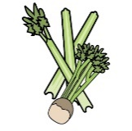 | 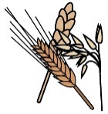 | 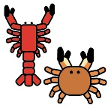 | 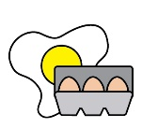 |  | 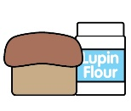 | 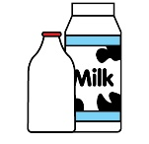 |  | 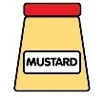 | 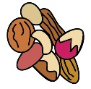 | 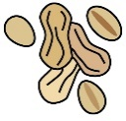 | 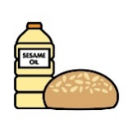 |  | 
 | Celery | Cereals containing gluten* | Crustaceans | Eggs | Fish | Lupin | Milk | Mollusc | Mustard | Nuts† | Peanuts | Sesame seeds | Soya | Sulphur Dioxide
Tesco Bourbon cream biscuits |  | X Wheat
Tesco Custard Cream Biscuits |  | X Wheat |  |  |  |  | X
Tesco free from choc chip cookies |  | X Oat |  |  |  |  |  |  |  |  |  |  | X
Tesco free from Shortbread biscuits |  | X Oat
Orange Squash |  |  |  |  |  |  |  |  |  |  |  |  |  | X

Review date: | 30/08/2026 | Reviewed by: | L BOYLE |  |  |  | You can find this template, including more information at www.food.gov.uk/allergy-guidance

