Breakfast Wrap Menu dishes and their allergen content

Dishes | 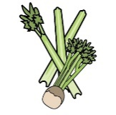 | 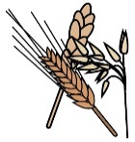 |  |  |  | 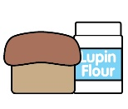 |  |  | 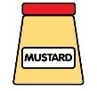 |  |  | 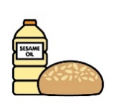 |  | 
 | Celery | Cereals containing gluten* | Crustaceans | Eggs | Fish | Lupin | Milk | Mollusc | Mustard | Nuts† | Peanuts | Sesame seeds | Soya | Sulphur Dioxide
Malt Wheats |  | X
Rice Snaps |  | X
Nestle Shreddies |  | X |  |  |  |  |  |  |  | MAY | MAY
Malted Milk Biscuits |  | X |  |  |  |  | X
Honey Hoops |  | X |  |  |  |  | MAY |  |  | MAY | MAY |  | MAY
Bagels |  | X |  |  |  |  |  |  |  |  |  | X | X
Crumpets |  | X |  |  |  |  | X
50/50 Bread |  | X |  |  |  |  |  |  |  |  |  |  | X
Tesco Biscuits |  | X |  |  |  |  | X |  |  |  |  |  | X

Review date: | 14/05/2026 | Reviewed by: | L BOYLE |  |  |  | You can find this template, including more information at www.food.gov.uk/allergy-guidance

Breakfast Wrap Menu Dishes and their allergen content

Dishes
 | Celery | Cereals containing gluten* | Crustaceans | Eggs | Fish | Lupin | Milk | Mollusc | Mustard | Nuts† | Peanuts | Sesame seeds | Soya | Sulphur Dioxide
Free From Yoghurts |  |  |  |  |  |  |  |  |  | MAY |  |  | X
Yoghurts |  |  |  |  |  |  | X

Review date: | 14/05/2026 | Reviewed by: | L BOYLE |  |  |  | You can find this template, including more information at www.food.gov.uk/allergy-guidance

