Wrap Menu dishes and their allergen content

Dishes | 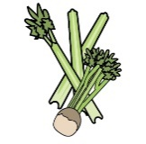 | 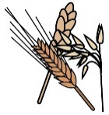 | 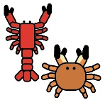 | 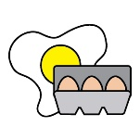 |  | 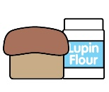 | 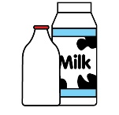 |  | 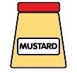 | 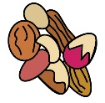 | 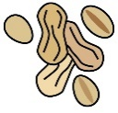 | 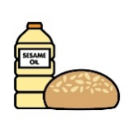 |  | 
 | Celery | Cereals containing gluten* | Crustaceans | Eggs | Fish | Lupin | Milk | Mollusc | Mustard | Nuts† | Peanuts | Sesame seeds | Soya | Sulphur Dioxide
Wraps |  | X
Pasta |  | X
Pesto |  |  |  |  |  |  | X
Cheese Pizza |  | X |  |  |  |  | X
Pepperoni Pizza |  | X |  |  |  |  | X
Heinz Tomato Ketchup | X
Cheese |  |  |  |  |  |  | X
Quorn Nuggets |  | X |  | X |  |  | X
Vegan Goujons |  | X |  |  |  |  |  |  |  |  |  |  | X

Review date: | 14/05/2026 | Reviewed by: | L BOYLE |  |  |  | You can find this template, including more information at www.food.gov.uk/allergy-guidance

Wrap Menu Dishes and their allergen content

Dishes
 | Celery | Cereals containing gluten* | Crustaceans | Eggs | Fish | Lupin | Milk | Mollusc | Mustard | Nuts† | Peanuts | Sesame seeds | Soya | Sulphur Dioxide
Vegan Rolls |  | X
Sausage Rolls |  | X |  | May |  |  | May |  | May
Chicken Goujons |  | X

Review date: | 14/05/2026 | Reviewed by: | L BOYLE |  |  |  | You can find this template, including more information at www.food.gov.uk/allergy-guidance

